Singin' in the Rain 1952
Please watch Singin in the Rain
Part 1
Explore how the medium of film brings this story to life.
This film assumes a visual medium that rounds up this whole story. The connection that this medium brings forth helps the audience contemplate the story in and out.
How is this musical enhanced by the way it is shot?
In a very modest way, Singin’ in the Rain gives its audience the necessary elements for a good musical – the establishment of what is real and what is not is carefully done and transitions between these are very smooth. What rises concerns when it comes to the structure of musical films is the structure itself. Through telling a story of people in the moviemaking business, opening a glamorous Hollywood movie premiere in the 1920s, the movie addresses structural issues successfully e.g. close integration of the songs and the story, frequent musical occurrences etc.
Are there certain scenes/shots in this musical that can only be captured on film? (In other words, they couldn't feasibly be achieved on stage every night.)
The six hours of fake rain every day of the 7 days that the film took to shoot. Water was mixed with milk to make them show great in film.
Discuss how the director's art makes the experience of this musical uniquely cinematographic – including its use of sound (other than song).
This film was directed by Stanley Donen and Gene Kelly. Kelly’s direction to choreograph the film and add charisma, joy and fun makes it a great one. The integration between the story and the music is unique and impeccable. The whole plot is satirical where musical numbers are wedded smoothly. Additionally, the mishaps of the transition to sound for the two actors and technicians further the theme. The director shows a great compilation of the film history and its musical numbers.
As always, provide at least one screen shot in your initial post, and analyze it closely both in terms cinematic techniques and mise en scene.
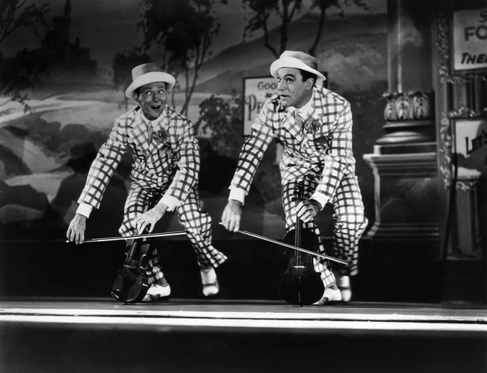
Part 2
Analyze the function of one song in this film. Does it forward the plot?
The song “Make ’Em Laugh” is the greatest in terms of how it is choreographed. Donald O’Connor made the wall flips with no special effects but it one of the best. O’Connor works on the piece tirelessly and he gets to do bits of acrobatic comedy (since he previously used to do such in vaudeville days). This song has some huge significance in this film in terms of entertainment and pushing the plot ahead.
Explain a character’s motives?
Reynolds is not statuesque in her performances and she could dance within the film. She is a short normal and a hard worker, a girl whose energy and talent made her stand out. Her motives was bring out the best of herself and this is explained in how she could dance alongside Kelly and O’Connor. Her character depicts a legendary performer.
Describe a relationship?
Reynolds is the female version of Gene Kelly in this film. Gene lies about his pre-Hollywood background. Reynolds lies about her career as a serious actress. Both characters assimilate in that they fabricate their credentials aiming to ratchet up respect and protect their reputation.
Comment on society, politics, or history?
“Make ’Em Laugh,” done by O’Connor portrays an amazing journey for force of slapstick dancing. It is literally about the American conflicts in silent comedy.
Provide comic relief? Something else? Explain. As always, choose at least two scenes to use as supporting examples for your argument. Screen shot each of them. Be specific in your analysis, include attention to mise en scene, and do not summarize.
I consider the song “Make ’Em Laugh,” the greatest comic relief in the entire film. O’Connor did it excellent and it is a big part of the film entertainment. Additionally, there is a great specialty in how the song is done but most of all.
